INTERNATIONAL PENGUIN CLASS
DINGHY
ASSOCIATION HANDBOOK



CONSTITUTION, BY-LAWS, SPECIFICATIONS AND
PENGUIN RACING RULES

,

October, 1968

·

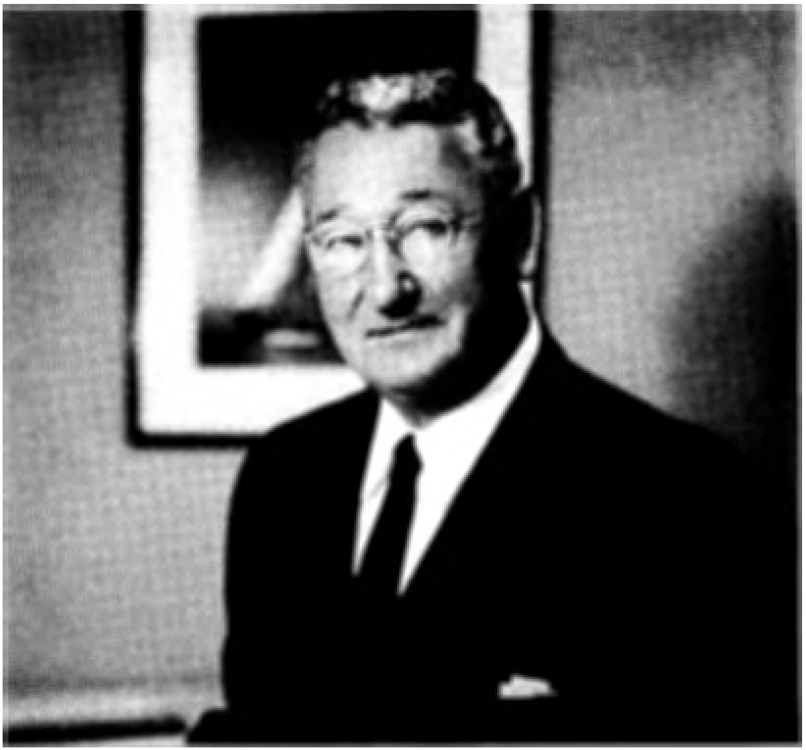

PHILIP L. RHODES, N.A.
HONORARY MEMBER, I.P.C.D.A.
Designer of the Penguin Class Dinghy

2

October, 1968

CONSTITUTION

ARTICLE I-Name
International Penguin Class Dinghy Association.
ARTICLE II-Emblem
The emblem shall he a black Penguin as shown on the official sail plan.
ARTICLE III--Objeci
To promote and develop Penguin Oass Dinghy racing under uniform rules governed by the Association, and rigidly to maintain the one design features of Penguin Class Dinghies.

ARTICLE IV-Policy
To keep the cost of construction, sails, and Association dues at a mini mum in order that Penguins may he available to the largest number of owners, and rigidly to maintain a strictly one design class.

ARTICLE V-Jurisdiction
The Association has jurisdiction over all Penguin Class activities. The Class Rules govern all sanctioned Penguin races, regardless of by whom held. The Constitution, By-Laws and Rules are binding upon all members and fleets, and all registered Penguin Class Dinghies must conform to the official plans and specifications.
ARTICLE VI-Membership
SECTION 1. Membership in this Association shall he restricted to those who own, sail, or are interested in Penguin Class dinghies. The members shall join through the fleets in whose waters they normally sail, except that persons situated where no organized fleet exists, may apply for membership directly to the Secretary of the Association. Others may apply to the Secretary of the Association, hut in such cases the membership shall become effective only after the application shall have been approved by the fleet to which said appli cant is eligible for membership. A dinghy and a member can belong to one fleet only.
SECTION 2. Active members of the Association shall he those who are owners, part owners, or bona fide charterers of measured and approved Pen guin Class dinghies. A bona fide charterer shall he one who has chartered a measured and approved Penguin Class dinghy for a period of not less than six months. Active members shall have the privilege of holding office and voting in fleet and Association meetings. They will receive a year hook and all other communications of the class. Only active members shall he entitled to sail as helmsmen in sanctioned races.
SECTION 3. Associate members shall he those who are interested in promoting the welfare of the Penguin Class Dinghy Association, hut are not entitled to active membership as above defined. All purchasers of plans or numbers shall he associate members for the balance of the calendar year with out further payment of dues or until their boats are measured and approved.

3

October, 1968

As soon as the boat is approved the owner shall be entitled to active membership and shall receive an active membership card for the balance of the current year u pon application to the Business Secretary, without addi tional cost. Associate members may sail as crew but are not entitled to the right to vote in fleet or Association meeti ngs. They shall receive a year book and all other communications of the class. They may substitute for the skipper at the tiller in an emergency or in a sanctioned race with approval of the race committee in a case of unavoidable absence of the regular skipper.
SECTION 4. Honorary members shall consist of those having rendered extraordinary service to the Association. They hall be elected by the Execu tive Committee, and shall have the privileges of an active member.
SECTION 5. Dues shall be fixed by the provisions of the By-Laws and must be paid before a member can be in good standing.
SECTION 6. Active membership shall be retained until the end of the calendar year, by active members in good standing who may suffer the loss of or dispose of their dinghy du ring the year.
ARTICLE VII--Organization
SECTION 1. The Association shall consist of individual members who shall belong to fleets, which in tu rn shall be organized into regions, the whole of which shall be under the jurisdiction of the Executive Committee.
SECTION 2. Any three or more owners of measu red Penguins may be granted a fleet charter u pon application to the Executive Vice President. Each fleet may elect its own officers, collect local dues, if so desired, and govern the affairs of the fleet consistent with' the Constitution and By-Laws of the Asso ciation.
SECTION 3. Each fleet shall be required to file an annual report of its activities and a complete roster of Fleet officers and members with the Secre tary of the Association during the month of January of each year, in order to renew its rights and privileges under its charter. Charters may be suspended at any time by the Executive Committee at its discretion, but can only be revoked at the ann ual meeting for failure to maintain in good standing the minimum of three boats necessary for a new fleet, or for adequate reasons.
Failure to submit a fleet report and roster of members by Januar y 30th
of each year, shall result in automatic suspension of Fleet Charter of the delinquent fleet. Fleet Charter may be reinstated only by the Executive Committee.
SECTION 4. Regions shall be established by the Executive Committee and fleets assigned to their respective regions by the President. Regions shall be established to incl ude a minimum of three active fleets within an area suited for normal regional activity ; provided, however, that special or pro visional regions may be established as warranted.
SECTION 5. Each region is expected to conduct an annual Regional Cham pionshi p Regatta open to (only ) all active members of the region, to hold an ann ual meeting to select a nominee for the appointment as Regional Vice President and to govern the affairs of the region consistent with the Constitution and By-Laws.
The name of the Regional Vice President nominee shall be forwarded to the Class President.
4

October, 1968

ARTICLE VII I-Officers- Titles, Duties and Method of Electing
SECTION 1. The Officers of the Association shall consist of the Presi· dent, Executive Vice President, Secretary, and Treasurer. They shall be nom inated at the annual meeting by the Nominating Committee or by nomination from the floor. Voting shall be by ballot and the candidate receiving a ma· jority of the votes cast for the office to which he is nominated shall be elected.
SECTION 2. PRESIDENT-The President shall preside at all meet· ings, shall be chairman of the Executive Committee, and ex-officio member of all other committees. He shall appoint Regional Vice Presidents and special committee members. He shall authorize the payment of all bills. He may request the Executive Committee to allocate funds for special purposes.
In the matter of the appointment of Regional Vice Presidents, he shall be guided by the nominations from each Region.
EXECUTIVE VICE PRESIDENT-The Executive Vice President shall have charge of promotional activities such as the development of the class, organization of new fleets, granting of charters, etc., and shall act in the absence of the President.
SECRETARY-The Secretary shall be in charge of all the secretarial work of the Association. He shall be responsible for the minutes of the meet· ings, records, general information, and correspondence. He shall be custodian of the Association's records and documents.
TREASURER-The Treasurer shall be in charge of the funds of the Association. He shall audit the Association Financial records twice each year.

ARTICLE I X-Standing and Appointed Committees
SECTION 1. STANDING COMMITTEE - The following Standing Committees shall serve for one year from November 1st to October 31st.
(a ) Executive Committee ( E. C.)-The Executive Committee shall consist of the Officers, and two Members-at-Large, who shall be elected at the annual meeting by the same procedure as outlined for Officers. Majority vote decides all questions if not otherwise stipulated, interprets Constitution and By-Laws, conducts all business, and determines policy of the Association, is the last court of appeal on disputes over Constitu· tional rights, and has the power to enforce its decisions by suspension of fleet or members. Decisions of the Executive Committee shall be final and binding.
( b ) Advisory Committee-The Advisory Committee shall consist of the two most recent Past Presidents still active in the LP.C.D.A. and the Regional Vice Presidents. The most recent Past President shall be the Chairman. The committee shall consider such problems as may be referred to it by the Executive Committee.
(c) Nominating Committee-The Nominating Committee shall con· sist of the immediate Past President as chairman, and two other mem bers, not officers of the Association, whom he shall appoint. The Nom inating Committee shall make its selections for the Office of President, Executive Vice President, Secretary, Treasurer, and two Memhers-at Large known to the Executive Committee at least one month in advance of the annual meeting, so that the proposed slate can he included in the

5

October, 1968
notice to the membership of said meeting. It shall be the duty of the Nominating Committee to see that its candidates are duly nominated.
SECTION 2. APPOINTED OFFICERS AND COMMITTEES -The
following officers and committees shall be appointed and serve for one year from November 1st to October 31st, or as stipulated by the E. C.
(a ) International Race Committee ( l.R.C.) -The International Race Committee Chairman, who shall be appointed by the Executive Committee, shall be a permanent Chairman and shall serve until he resigns or a new Chairman is appointed. The International Race Com mittee shall consist of at least four ( 4) additional members appointed by the Chairman and approved by the Executive Committee. It may consist of members of the Executive Committee that can be present at the Inter national Championships and eligible to :;erve by reason of not being contestants. The I.R.C. shall supervise and conduct the International Championship Regatta in accordance with the Rules Governing the Inter national Championship, and the decisions of the I.R.C. as to matters concerning the current regatta shall be final.
( b ) International Measurement Committee ( l.M.C.) -The Interna tional Measurement Committee shall consist of a chairman and such additional members as may be appointed by the Executive Committee. Shall receive and approve or reject measurement certificates in accord ance with the tolerances established by the Executive Committee, and shall maintain a file of the measurement certificates for each measured boat. Shall forward to the boat owner via the Business Secretary, the duplicate copy of the certificate. Shall answer all correspondence rela tive to measurements, building materials, new or peculiar methods of construction, etc.
( c ) Regional Vice Presidents- Regional Vice Presidents shall be appointed by the President, shall be the senior executive officer of their region, and shall have charge of Regional Regattas and Meetings, and of promotional activities leading to the formation of new fleets within the region and shall serve on the advisory committee.
( d ) Director of Publicity-The Director of Publicity shall be ap pointed by the President and shall receive items of general interest from fleets for magazine and newspaper publication. He shall be responsible for the publication of the year book and such other bulletins as the Executive Committee may direct. The Director of Publicity may appoint such other assistants as he deems necessary.
(e ) Business Secretary-Treasurer- He shall receive all dues and fees for plans and numbers, etc. He shall be responsible for issuing plans, membership cards and assignment of numbers. He is authorized to disburse funds up to the amount of $200 for any one bill; disburse ments in excess of this amount shall be made only on the authorization of the President.
(f ) Special-Officers or Committees-Special Officers or Commit tees, including special race committees for sanctioned events, may be appointed at any time by the President.

6
ARTICLE X-Meetings
SECTION 1. The annual meeting shall be held during the period of and in the vicinity of International Championship Series, if possible. Special meetings shall be held upon order of Executive Committee or upon demand in writing by twenty-five per cent of the fleets. Exact time and place of all meetings shall be fixed by the Executive Committee.
SECTION 2. Notice must be sent to the members in time to permit action, and if a Special Meeting be called, the purpose thereof must be stated in such form to permit voting by mail and no other business shall be transacted.

ARTICLE XI-Voting
No fleet shall cast more than 25% of the votes cast. Membership books close ten days before the meeting or as ordered by the Executive Committee. Proxies must be in writing and must be submitted by mail to the Secretary two days before the meeting. All members present and all proxies shall vote unless excused by the chair. A majority of the votes present shall decide all questions not otherwise stipulated, and the chair shall cast the one deciding vote in case of a tie and may fix a time limit on speakers and motions.

ARTICLE XII-Quorum
Twenty members present in person or by proxy which shall include representation from at least 25% of the fleets shall constitute a quorum.

ARTICLE XIIl--Order of Business
- Call tc;i order.
- Roll call of fleets.
- Minutes of last meeting.
- Reports of officers.
- Charters, ratified and revoked.
- Unfinished business.
- New business.
- Election of officers for the following year.
- Adjournment.
ARTICLE XIV-Amend ments
Amendments may be proposed by a majority of an annual meeting or at any time by the Executive Committee. The vote must be by mail to the entire membership and a majority of the votes received shall determine the adoption or rejection of the proposed amendment.

7
BY-LAWS
ARTICLE I-Dues
  - The annual dues for Active and Associate Membership shall be five dollars ($5.00) payable January lst.
- Fleet dues are optional, and if any, are to be kept by the fleet.
- Members whose dues are in arrears for 90 days shall be automatically suspended.
- In order to participate in any Penguin race, regardless of by whom held, a member's current annual dues must be paid. A skipper who has not paid his dues shall be subject to protest as not conforming to Class Rules and the responsible race committee shall have no other recourse but to uphold the protest.
ARTICLE II-Eligible Boals
A boat is eligible and considered in the Penguin Class, only if it con forms to the measurement rules as certified by a class measurement certificate, has been properly registered, and is owned by a qualified active member or members recorded at the time as in good standing with the Association.
ARTICLE III- Boat's Number and Name
I. Official number, allotted to new boats, and on application to the Business Secretary, shall be permanent and affixed to sail and cut into side of centerboard log or keel, with letters at least two inches in height. Name is optional, but must be recorded and approved.
- If alterations are made and affect more than one-half of the hull, or are sufficiently extensive to warrant, in the opinion of the measurement com mittee, a new number shall be awarded and the boat shall be considered new as of such date. Such altered boat shall be re-measu red and be subject to restrictions and governing measurements then in force. Registration must then be obtained in the usual manner.

ARTICLE IV-Plans
  - The cost of official plans shall be fifteen dollars ($15.00) .
- The application for a number must be accompanied by a check for ten dollars ($10.00) to cover the number tax.
- The purchase of plans or payment of numbering tax entitles the pur· chaser to associate membership without further payment of dues for the current year.

ARTICLE V- M easurements and Certificates
  - No boat shall be eligible to enter any sanctioned race for the Penguin Class until measurement certificate has been granted for such boat.
- Measurements shall be made by the owner, builder, or a measurer of a Yacht Club.
- This measurement sheet shall be forwarded in duplicate to the Chair· man, International Measurement Committee, who shall approve or reject the boat as a class member accordingly if boat is within or beyond the building tolerances established by the Executive Committee.

- Boats shall he subject to re·measurement as to dimensions and data on the measurement sheet, upon protest. The person protesting shall post a bond of $2.00 as evidence of good faith which shall he used to pay measurer if the measurements are in accordance with those submitted on the measure ment sheet. If the dimensions fail to check with those submitted on the meas urement sheet, the bond shall he returned and owner shall pay re-measurement fee, which shall not exceed S2.00. Re-measurement shall he made by the measurer of the Yacht Club having control of the races, or a measurer appointed by the Race Committee having control of the races.

ARTICLE VI-Regulations
1. Ballast-No dead ballast shall he allowed except as permitted by Paragraph 3.
- Equipment-The following equipment must he carried in all races:
  - Two wearable life preservers, but no ski belts.
h. A serviceable pair of oars, not less than 5' long, with properly installed oar locks and sockets.
- A painter not less than 3/s" diameter and 15' in length if of
hemp or cotton, and not less than o/i. 6" diameter and 30' in length if of synthetic fibre ( nylon, orion, dacron ) .
- Adequate means of hailing (scoop or can ) .
- An anchor at least two pounds in weight, except responsible race committee may waive this requirement if there is no continuing current or if the depth of the water makes use of an anchor with a 30 foot anchor line impractical.
- Skipper and Crew-A dinghy shall be raced with a crew of one in addition to the helmsman, except as noted below. In all sanctioneCl events the helmsman shall be an active member and the combined weight of the skipper and crew when dressed for sailing shall not be less than 275 pounds. To make up this total, 40 pound of ballast may be carried and may be composed as follows: 25 pounds of ballast which may be buoyant or non-buoyant and 15 pounds which must be buoyant. If any non-buoyant ballast is used, it should he carried in such a fashion that it will most readily fall free of the boat in the event of a capsize. In the event of junior sailor or others whose combined weight does not equal 275 pounds including permanent ballast, the ballast may he omitted and a third person carried to provide the required weight. In all such sanctioned events, no change shall be made in skipper or crew except in cases of real illness, accident, or other cause satisfactory to, and approved by, the race committee.
- Sails--A boat is entitled to not more than two sails for racing pur poses commencing at the time the boat is acquired. No more than one replace ment sail may be acquired in any calendar year. There shall be no borrowing of sails at sanctioned events without prior approval of the Race Committee.

ARTICLE VII-Sanctions
- Sanctions for National and International Championship Regattas shall he granted by the Executive Committee.
- Sanctions for Inter-regional Championship Regattas shall he granted

9

by the Executive Vice President, with the approval of the Vice Presidents of two of the Regions to be represented.
- Sanctions for Regional Championshi p Regattas shall be granted by ,,..\
the Regional Vice President, with the approval of the Fleet Captains of two- thirds of the fleets of the region.
- Sanctions for Special Championship Regattas sponsored by organ· izations other than the I.P.C.D.A. shall be granted by the Regional Vice President for the region or by the Executive Vice President if outside an established region.
- Sanctions are not req uired for Penguin Class Dinghy races held as part of regattas sanctioned by one of the various Yacht Racing Associations; however, entries in these events m ust conform with all qiembership and meas· urement requirements, and with Article VI-Regulations.
- Copies of all sanctions shall be filed with the Secretary, together with a copy of all race results.

ARTICLE VIII-Honor Awards
  - Honor awards shall be displayed on sail as indicated in the following sketch and shall be of the proper color, size, and number as req uired by the following classification of events:
Class A-The International Cham pionship-Gold Awards-First, Second, and Third place skippers entitled to wear three, two and one gold chevrons respectively.
Class B-North American Championship-Silver awards-First, Second and Third place skippers entitled to wear three, two and one silver chevron respectively.
Class C-An inter-regional championship wherein at least three regions
are represented-Blue awards-First, Second, and Third place skip· pers entitled to wear three, two, and one blue chevron respectively.
Class_ D-A regional championship wherein at least three Aeets are repre· sented-Red awards-First, Second, and Third place skippers en· titled to wear three, two, and one red chevron respectively.
Class £-Fleet Cham pionship-winner of Aeet championshi p series en· titled to wear one black chevron.
- The year in which the award was won must he displayed under the chevrons or chevron as indicated in the following sketch, i.e., 46 for 1946, 47 for 1947, etc.
- Awards rank in the following order:-gold, silver, blue, red, and black. Thus one blue chevron outranks three red chevrons. Only the highest award ever won shall be displayed and if the same event is won twice, the latest date shall be displayed under the chevrons.
- Awards are made to the skipper, not to the boat, and are retained by the skipper, if the boat is sold, for use on any other Penguin Dinghy he may own while still a member of the Association.
ARTICLE IX-Rules Governing the International Championship
- Pur pose- T o determine annually the championship of the entire Pen· guin Class by bringing together, insofar as possible, the best skippers from every fleet.

IO

l'ENSUIN

Ae/ NG /1/N6H'I'
SAIL l'L AN .IHOW'tN• LOC /ll rtoN
or 'iONOlll AW'111r11.3
.l'AT : J(,." • t!• 0 #A-I ,,...,.. /'4
I .,,,,.,, ,..,
lfl'Vl•I• ,.1.A

NOr1s
/. AWAlfO SHoWll IS TllAT A:llllf
IH I L61T C#Altfllilltlll
.. .r,; " ,,,,, ••.., ,,, ""'
,,, , •II r11• ,t111 "I M1•1<11r,11
1"r'"1'r11". •1•·•••M ''"'r""n
·-·-.,
l lNM61A. I
L.. -.-·..J

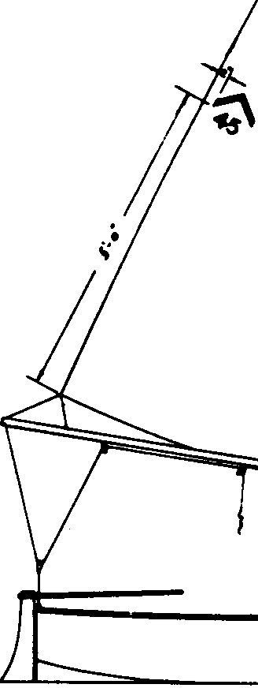
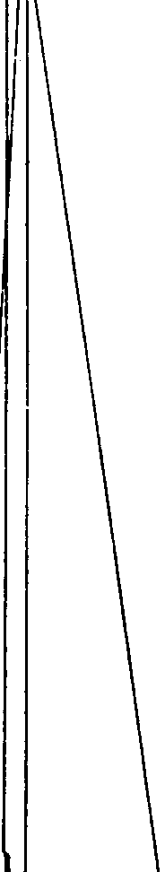
•·A_.,,.....'.4,191 .,...,,... NM
.,..•.,.•111r••111ra...,,.

11

October, 1968

HONOR AWAR DS

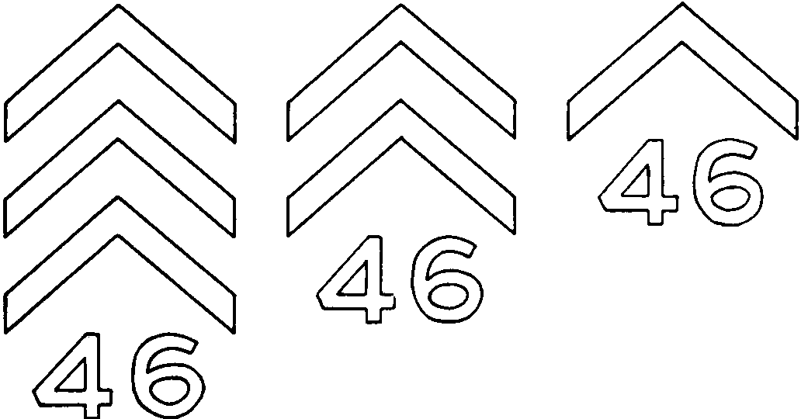

Chevrons and year in gold for Class A event such as International Championship silver " " B '' North American Championshi p

" " bl ue " " C "
- " red " D "
- " black " " E "
Inter Regional Championship Regional Championship
Fleet Cham pionship

D&TAIL OP CMf.VROM MID •Ullll9U

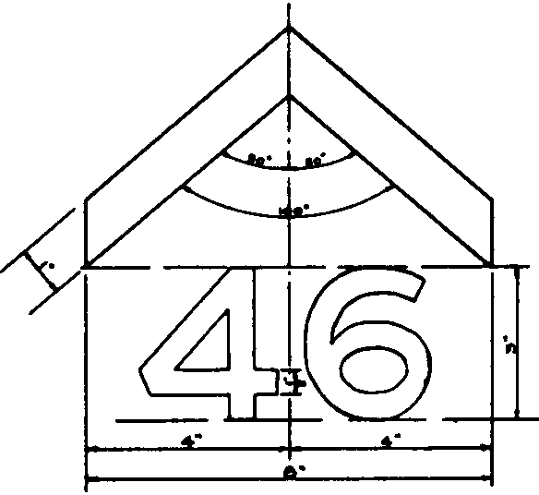

12

October, 1968



- T rophies- Perpetual and Others-The name of the perpetual trophy shall be the "International Championship Trophy" which shall be held by the winner until the next series subject to the Executive Committee's approval and order. Other trophies shall be awarded by the I.P.C.D.A. and/or Fleet sponsoring the Regatta as shall from time to time be practicable.

Ent,ries
  - ) A fleet having 3 or more boats sailing in the majority of races in the local elimination series of at least 5 races shall be entitled to enter the winning boat in the International Regatta.
( b) A fleet having 7 or more boats sailing in the majority of races in the local elimination series of at least 5 races shall be entitled to enter the winning boat and second place boat in the International Regatta.
( c) A fleet having 11 or more boats sailing in the majority of races in the local elimination series of at least 5 races shall be entitled to enter the winning boat and the second and third place boats in the International Regatta.
( d ) A fleet having 15 or more boats sailing in the majority of races in the local elimination series of at least 5 races shall be entitled to enter the winning boat, the second, the third, and the fourth place boats in the International Regatta.
(e) A fleet having 20 or more boats sailing in the majority of races in the local elimination series of at least 5.races shall be entitled to enter the winning boat, the second, the third, the fourth, and the fifth place boats in the International Regatta.
(f) A fleet having 25 or more boats sailing in the majority of races in the local elimination series of at least 5 races shall be entitled to enter the winning boat, the second, the third, the fourth, the fifth, and the sixth place boats in the International Regatta.
(g ) The International or North American Champion of the preceding year shall be entitled to enter, regardless of his position in an elimination series. ( Note: There will be a North American Cham pion only when the International Championship is held in South America, per Article IX 4.) If he shall win the elimination series in his fleet, the runner up, or runner up and third place boat, or runner up and third and fourth place boats, depending on the size of the fleet as outlined above shall be entitled to enter.
- ) In the event that a boat is unable to compete, a Fleet may substi tute another boat as determined by the order of their standing in the local elimination series.
- When any boat is eligible to compete in the International Re gatta, but cannot compete because of the inability of the owner to transport same to the place of competition, such owner may make arrangements with the approval of the Executive Commit· tee, to charter a boat and compete in the International Regatta, provided he shall use sails with his registered number thereon, and in this event it shall be considered as though said Skipper's registered boat were competing in the Regatta. Application for such an arrangement shall be filed with the Executive Committee

13

October, 1968


prior to the time limit for naming entries.
(j) The number of entries to the Championships shall be determined as above except: when the Internationals are held on the East Coast, the entries from Regions I, II, and III only shall be deter mined from the results of the Regional Championships for those Regions. The total boats from those Regions shall be 34 or 35, whichever rounds off better, and the number of entrants from each of the three Regions shall correspond directly to the number of registered, active boats in those three Regions as of May lst of the year concerned. Fleets in all other Regions will continue to be bound only by the instructions in par. 3 (a ) through ( f ) . Subparagraph 3 ( g) will govern at all times.
( k ) A aximum of five additional entries shall be allowed from members who satisfy the following conditions:
( i ) Cannot participate in a fleet or regional elimination series or live within 100 miles of the site of such a series.
(ii ) Must be currently an active member and have been an active member in the preceding year.
( iii ) Must request from the Business Secretary and return by May 15 a special entry application. Each application shall be approved by the Executive Committee. In the event more than five applications are received, the Execu· tive Committee shall select five participants, giving pref erence to those who have entered previous International Championships with consideration given to their final position in these events.

- Place
( a) It shall be the duty of the Executive Committee to award the holding of the International Championship races to South Amer ica every fifth year (1970, 1975, 1980, etc.) The International
( or North American Championship ) , moves on a four-year cycle to the Mid-West, Gulf, West and East Coasts. The rotation is subject to review if any site-Region fails to maintain at least four or more fleets in good standing or if a further change in the center of gravity of the Class is found to call for such a review.

The I nternational Championship Regatta shall be held, each year, in the home waters of the fleet winning the Regional Cham pionship series the previous year.

( b ) Notwithstand i ng the provisions of the foregoing, if the winning fleet is un willing, unable, or deemed inadequate to hold the event, then the Executive Committee shall award it to such other fleet in the same region, if possi ble, as may be most fitted to hold it.
14

October, 1968

-- ····· ·-·-· ----·-----·-- ---------
5. Home Fleet- The responsibility for arranging and providing for proper facilities, prizes, entertainment, housing, etc., shall rest with the fleet on whose waters the series is held. In this regard it must cooperate with and be guided by the Executive Committee.

Conditions Governing Race
  - ) The International Championship shall consist of five (5) com· pleted races. This nu mber shall not be changed except that, in the event of very extreme weather conditions which would un d uly prolong the du ration of the series, the number may be reduced to not less than three ( 3) completed races by a th ree. quarter (%) ma jority vote of the skippers entering the series.
( b ) Held in open water so as to minimize the advantage of local knowledge relative to headlands, shoals, obstructions, etc. If unavoidable, aids to navigation, unless otherwise ordered, must be lef t on the required or channel side.
- Courses: A triangular or windward-leeward and return total· ing approximately 3 nautical miles and alternated if practicable. Committee Boat should be located in the middle of the windward leg. If two laps are necessary, participants need not pass through the starting line on their second lap. A Gold Cup course is also permitted, with the finish preferably on the wind.
- Procedure: Signals, starting line, general procedure, etc., to be in accordance with LY.R.U. Racing Rules.
(e} Time Limit: Two and one-half (21;2 ) hours. If one boat finishes within time limit all must be timed.
- Racing Rules: The I.Y.R.U. Racing Rules as modified herein shall apply.
( g) Team Racing Tactics: The act of deliberately and wilfully sacri· ficing one's own chances or place in a race, thereby substantially infu ring or improving the chances or place of others, is barred and shall be grounds for disqualification. Covering or luffing, providing a yacht is sailed within the right·of -way rules and in a manner consistent with maintaining or bettering its own stand· ing in the race or point score, shall not be deemed team racing tactics. In flagrant cases, affecting the point score among leaders, the Race Committee shall have the power, with or without pro test, to order the race resailed, ban the offender from the resailed and remaining races and recommend his or her suspension to the Executive Committee.
- Eligibilit y- NOT E : Consult carefully Constitution and By-Laws on membership qualifications and other details affecting eligibility.
( a ) No boat shall be permitted to compete in tpe International Re gatta whose record of official measu rement is not in the files of this Association, and no boat shall be permitted to compete in a race whose owner or owners shall not certify that no changes, in construction, or new sails beyond lawful allowances have been made since the last official measurement, except such changes as

15
have been officially measured and certified. Sails, spars, and such other items as may be considered necessary by the Execu tive Committee will be subject to measurement at the Interna tional Regatta. Not more than two suits of sails will be allowed each contestant at the International Regatta.
  - Skipper ( Helmsman ) must : (1) Be an active member, be en rolled in the ffeet he represents, be a bona fide owner, or desig· nated syndicate representative of boat to be sailed by him. ( 2 ) Have sailed his own boat in a representative n umber of Penguin races within a year, and by reason of residence or normal yacht· ing activities be qualified to represent that locality. Requirement ( 2 ) may be modified by the Executive Committee for the newly formed ff eets and service ff eets.
  - ) Crew : It is recommended that the crew be an associate or active member enrolled in the ffeet he represents, come from, and be qualified to represent that locality.
(d ) No changes shall he made in the skippers or crews during the International Regatta, except in cases of serious illness, accident or other ca use satisfactory to. and approved by, the Race Com. mittee.
- Protests and Hearings
  - ) The l.Y.R.U. Racing Rules as modified herein shall apply.
  - Subject to the modification set forth in Article XI, protests and hearings shall he in accordance with Part VI of the l.Y.R.U. Racing Rules except that a contestant intending to protest shall notify the l.R.C. immediately upon finishing the race of his intention to protest and give the racing number of the yachts involved. The protest shall be in writing and delivered to the
l.R.C. as soon as they come ashore. A protest ffag is required in accordance with l.Y.R.U. Rule ms.
  - ) There shall he no appeal from the decisions of the International Race Committee.
- Notices- Official notice of hearings, decisions, rulings, changes in procedure, and instructions shall be served u pon all parties by post ing on bulletin board at headquarters daily during series. By due notice, time and place may be varied because of confficting condi tions. Responsibility of being at Headquarters and seeing notices at given hours rests with contestants and sub-officials.
- Points-Scoring shall he in accordance with Article XII of the By-Laws.
- General Procedure
( a ) All instructions and regulations not fully described in the Inter national Championship Rules shall he published in the Race Circular.
- International Race Committee (l.R.C.)-The International Race Committee Chairman, who shall he appointed by the Executive Committee, shall be a permanent Chairman and shall serve until he resigns or a new Chairman is appointed. The International
16
Race Committee shall consist of at least four (4) additional members appointed by the Chairman and approved by the Exec utive Committee. It may consist of members of the Executive Committee that can be present at the International Champion ships and eligible to serve by reason of not being contestants. The LR.C. shall supervise and conduct the International Cham pionship Regatta in accordance with the Rules Governing the International Championships, and the decisions of the l.R.C. as to matters concerning the current regatta shall be final.
- ) The International Race Committee shall have supervision of the selection and laying out of the course and general conduct of the Regatta. All other details in connection with the holding of the International Regatta, such as place, shall be submitted to the Executive Committee for approval and sanction.
( d ) The decision of the International Race Committee as to selection of courses and conduct of Regatta shall be final.
( e) Timers, starters, and other officials may be appointed from the local Regatta Committee by the I.R.C.

ARTICLE X- Specifications
1. These specifications describe the construction of the Penguin Class Dinghy and must be adhered to. The Official Plans show an approved method of construction as to details and sizes; however, these specifications give the minimum sizes which are allowed. The materials of construction are optional except as specified. The sizes of members are optional except as specified. WHERE ANY POINT OF DIFFERENCE EXISTS, THE SPECIFICATIONS AS WRITTEN IN THE HANDBOOK SHALL BE FINAL, AND NOT THE PICTURED DESCRIPTION AS SHOWN IN THE PLANS. To qualif y in sanctioned races, a Penguin Dinghy must conform to these specifications.
la. General-The dimensions and shape of the hull shall be in accordance with the official plans. The boat and all of its parts, except as otherwise specified, shall be constructed of wood with a weight of not less than 20 pounds per cubic foot at 15 per cent moisture content. Suggested woods are not a req uirement but it is recommended that the lighter woods such as spruce, cedar, African mahogany, and fir be utilized. All plywood shall be phenolic resin bonded hot pressed waterproof plywood. THE COMPLETELY FI N ISHED HULL, INCLUDING CENTERBOARD, SHALL NOT WEIGH LESS THAN 130 POUNDS.
2. Fiberglass Boats. Notwithstanding the provisions of par. la, above, the hull and its p·arts may be built of fiberglass reinforced laminates. THE COM PLETELY FINISHED FIBERGLASS HULL INCLUDING THE WOOD CEN TERBOAR D AND FLOORBOAR DS SHALL NOT WEIGH LESS THAN 137 POUNDS. All the provisions af Article X not pertaining to the hull, i.e., par. 16 through par. 25, together with pertinent amendments, remain unchanged. 2a. Fiberglass lamination methods, while undefined in detail, shall be sufficient to provide a hull of high structural integrity ·commensurate with
- weight consideratJ.ons. The Class reserves the right to reject Fiberglass Penguins which in their opinion do not have good structural qualities.
17

October, 1968
2a (1) . In monocoque (single-layer ) lay-ups, the hull must be at least
%2 " thick. The equivalent of at least 1.7 cubic feet of permanent flotation of 2 lbs. per cu bic foot den ity shall be placed u nder the mast partner, thwart,
and floorboards or elsewhere as practicable. Floorboards are required in ac cordance with paragraph 19.
2a ( 2) . Sandwich construction lay-ups are also permitted, in which case the sandwich-constructed area of the bottom shall cover at least 16 square feet of the bottom and no additional floorboa rds a re required. Wherever the bottom
or other part of the "skin" of the boat is not sandwich constructed, it shall be at least % 2" thick. Material within the sandwich should have a very high
percentage of non-interconnected cells or be coated in small-sized units with a waterproof sealant all around before lay-up. Flotation for sandwich-constructed boats must add up to at least the equivalent of 1.7 cubic feet of 2 lbs. per cubic foot density including the flotation within the sandwiched areas.
2b. The Penguin may be fabricated of fiberglass only by fabricators ap proved by the Fibergless Committee. Molds may only be made from a meas ured Penguin hull or plug which has been specifically approved as a plug for a fiberglass mold by the Class Measurer.
2c (1) . The "sheer clamp" or deck mold u nit ( this includes rails, gun wale, thwart, mast-pa rtner, bulkhead breasthook and quarter knees) is to be made according to the Class plan for the sheer clamp ( deck mold ) and so con structed as to provide structural integrity comparable to that of a standard wood boat. Any changes from the plan must be specifically approved by the Fiberglass Committee.
2c ( 2) . It is permissible to use wood parts instead of fiberglass for the thwart, gunwale, mast partner, knees, fenders and mast step. The wooden mem bers, when used, must conform to applicable wooden specification dimensions. Norwithstanding this, the skeg may be wood covered with fiberglass or wood only.
2d. Builders' obligations: Approved fiberglass Penguin manufacturers must submit a complete builder's method of construction to the Fiberglass Committee before any boats can be sold or numbers assigned. If at any time an approved builder wishes to make substantial changes in his previously approved method of construction, he is required to submit the revised method of construction to the Fiberglass Committee for approval.
2e. Developmental Boats. The Fiberglass Committee is empowered to authorize a recognized Fiberglass Builder to build up to two developmental boats using a specific departure from his normal method of construction and FROM EXTANT SCANTLING SPECIFICATIONS. When these boats are properly mea·su red in and certificated with a scantlings waiver from the Fiber glass Committee, they may be granted a number with the suffix "D" which shall be drilled with the number into an appropriate place in the boat as usual. The developmental boats may then be sold on a "caveat emptor" basis and raced as Penguins. If these boats are determined to be satisfactory in perform ance and construction after inspection by the Fiberglass Committee Chairman or his designee; upon application by the builder to the Fiberglass Committee, the method of construotion used on them shall be approved for regular use.
2£. "Group builders," such as members of a yacht club, may apply to the

18
Fiberglass Committee for permission to fabricate. The construction of fiber· glass Penguins by individuals is not approved.
2g. If track is to be used for the shrouds, it is to he bolted through the sheer flange of the hull and the sheer clamp. Extra reiniorcing is then re· quired at this point. To accommodate the headstay fitting, a wood block can be welded to the inner stem. At the transom, a 4" wide wood stiffener is welded to the interior of the transom to accommodate the bolts for the rudder gudgeons. Blocks of wood are placed between the hull and the gunwale to accommodate the oarlocks.
2h. APPLICATIONS: I n order to obtain approval to fabricate, a builder should :
  - Address his request to ·the Chairman, Fiberglass Committee.
  - Present a brochure or short resume giving his experience in glass plastic fahrica ti.on.
  - Agree to fabricate according to procedure outlined above.
  - Provide a sample panel ( approx. 18" X 18") of his lay-up for testing.
5. Indicate the scope of his expeoted sales market. His letter should be accompanied by any suggestions he may have which he considers to be improvements over the stipulated procedures and specifications.
- Wood Boats. Keel-Keel may be made of one piece or two pieces, hich shall have a total molded dimension of not less than %" and a total sided dimen· sion of not less than 53,4" in way of the centerboard trunk and tapered at the ends.
The tapering shall be in such a manner that at each station the half breadths
of the keel on the inside of the boat shall he not less than those distances shown by the table of offsets for the half breadths of the rabbet line plus %".
( Example: Width of the keel on the inside of the boat at station 6 equals 2 ( 11Yi 6 + % ) 51/s ) . However, the keel may be %" thick if it is completely covered by the plywood. The width of the keel at the how shall he not less
than that shown for the width of the stem piece.
- Stem-Stem may be in one piece or two pieces. The size inside the rabbet shall he not less than that shown on the full sized plan. The stem cap may be molded to not less than %" radius.
- Transom-T he transom may be made of plywood or solid lumber. If made of plywood it shall have a thickness of not less than %" and shall have framing not less than %" X 2" completely around the edges. Plywood tran· soms in addition to this framing shall have a center stiffener of not less than
%" X 4". If the transom is made of solid lumber, the thickness shall be not less than ry{'.
- Knees-The stern and transom shall be adequately secu red to the keel by means of knees. The knees shall he sided not less than %" and shall be of the outline shown on the full size plan.
- Chines-T he boat shall be fitted with two chines. The chines may be i n one piece of rabbeted construction, two pieces as indicated on the plans, or a single piece entirely inside the planking. The chines shall be not less than %" X 1%" inside the planking. The exterior radius of the chine shall
not exceed %". Chines may be beveled only to the extent necessary to allow
d raining when the boat is on an even keel provided they are not less than
2" in width.
l Q
- Frames- Frames shall be fitted in number and location as indicated in the official plans. All frames shall be sided not less than %" their full length exclusive of gussets. Side frames Nos. 1 and 2 shall be a full '2" their
full length ; other frames shall be not less than 2" at the chine with a straight taper to not less than 11/z" at the head. The inwale may be omitted, if so the top of the frames on the inboard side may be rounded to not more than a l" radius. Bottom frames shall be molded not less than 2" over the top of the keel, tapered to not less than 11/z" at the chines. Side frames and bottom frames shall be connected by plywood gussets not less than 4" on each leg
and material not less than %" thick. If a lap joint is used to connect the frames there shall be one gusset placed between the side frames and the bottom frames, if a butt joint is used there shall be two gussets, one placed on each side of the joint. The inboard edge of the gussets may be rounded
from end to end to smooth curve. Distance from inside top corner of chine to nearest point on radius of gusset shall be not less than 11/z inches. Side-frames
No. 1 may be curved along the outer edge of maximum of 3/8"; point of maxi mum curvature to be mid way between chine and gunwale.
9. Gunwale-A gunwale shall he fitted and shall be not less than
%" X l". When a gunwale is fitted as a rail cap, or a rail cap is fitted, its width inboard of the inside of the planking shall not exceed 11/z" measured perpendicular to the planking. Reinforcing or track rail between frames 1
and 3 is not considered part of the gunwale. Oarlock sockets shall be installed. 10. Fender-A fender of not less than 1/z" X l" shall be fitted. The maximum width dimension shall be determined by the following rule ; The
maximum total width of the fender, plus the thickness of the plywood skin,
plus the gunwale, shall not exceed 4" forward of frame number 2; from this point af t, the width shall be reduced to a maximum of 3" at the transom.
- Thwart-A thwart of not less than %" X 5%" (or equivalent cross sectional area ) shall be fitted. The thwart shall be located between stations 3 and 5, and attached to the centerboard trunk at least 10'' from the top of the keel.
- M ast Partner-A mast partner not less than %" X 5%" (or equiva lent cross-sectional area ) shall be fitted. This X-sectional limitation shall be adhered to in way of the opening for the mast. The mast partner shall be located as illustrated in the plans and shall be at least 14" above the top of the keel. The mast must pass through the mast partner.
- Breasthook and Knees-T he gunwale shall be attached to the stem by means of a breasthook and to the transom by means of knees all being not less than %" thick and not less than 6" on each leg.
- Planking-Side and bottom planking shall be %" phenolic resin bonded hot pressed waterproof plywood.
- Centerboard logs-Centerboard logs shall be sided not less than %"
and shall be molded not less than shown on the full size plan.
15a. Centerboard T runk-Centerboard trunk sides shall be not less than
%" plywood and shall extend vertically a sufficient height to completely house the centerboard.
- Centerboard-T he centerboard shall be of wood except for loading which may be added to overcome flotation, in which case the negative buoy-

20

ancy shall not exceed 2 pounds. The outline shall be that shown on the official plans. The thickness shall be not less than %". The centerboard may be streamlined except for that portion which remains above the bottom of the keel when the board is down 90 degrees, and may be controlled by a lever or other method as long as the axis about which it pivots is fixed at the point shown on the plans. No method of filling or covering the bottom of the centerboard trunk is allowed. The top of the centerboard trunk may be enclosed when a centerboard actuating mechanism is used.
- Rudder-T he rudder outline shall be in accordance with the rudder . plan effective 1 January 1950 except that arangements may be made to raise the rudder blade to facilitate beaching. However, during a race the adjustable rudder blade shall be carried in the position as shown on the plan. The thick ness of the rudder must be as specified along line "A-A" of the plan and above the line shown for the lower edge of the cheek pieces. The specification for the thickness is as follows: "The rudder may be 3;4" thick if fitted with adequate
cheek pieces made of wood, otherwise it shall be %" thick. The wood cheek pieces shown on plan are the minimum in thickness and extent that shall be
deemed adequate. If the rudder head is mortised for the tiller, the cheek piece shall be not less than 3/8" thick. The rudder may be streamlined below th·
lower edge of the cheek pieces but must have a minimum radius of 1/s" along
the leading edge and a minimum of %2" along the trailing edge. The rudder with tiller attached shall float. Metal cheek pieces not less than i 6 " in thick ness may be substituted for wood.
- Skeg-T he skeg shall be fitted as shown on the plans; sided dimen sions not less than 3;4", 4'' deep at the end of the keel, l" deep at station 7, terminating 3112" forward of station 7. The skeg shall not project beyond the finished after face of the transom.
Maximum sided dimension shall be no greater than %".
The skeg may be tapered af t from a point 3" forward of the af ter end. 19. Floorboards- Floorboard s having a total area of 16 square f eet
(excluding slots between boards ) , capable of supporting a 150 pound person standing midway between frames, shall be fitted. Solid %" plywood floor boards having an area equal to 16 square feet may be used if desired.
20. Decks-N o decking, washboards or coamings are permitt d. A fabric spray hood forward of Frame 2 may be fitted. No more than two l" X %" battens may be used for the spray hood. The spray hood shall be raised no higher than 6" above the sheer line at the mast.
  - Spars-General :
Spars shall be solid wood (for exceptions see 21.3 and 21.5) . In their normal state, they must be straight, no steam bending of either the mast or boom is allowed. The mast may be joined or in one piece.
  - Mast Dimensions:
    - The top of the mast, including halliard attachment, shall not ex tend beyond a height of 19' above the top of the keel.
    - The maximum fore and af t dimension of the mast, including the luff rope tunnel, shall not exceed 31/2".
    - The minimum thickness from a point 8' below the top of the mast
(lower limit on attaching stays) shall not be less than 1%" except that it may
21
be tapered, sta rting 17" above the butt end, to a minimum of l" in diameter at the bu tt end.
    - A luff rope tunnel of not more than %" in diameter for the luff
of the sail may be incorporated in the mast.
    - The mast shall be plainly marked with contrasting bands %"
wide, and the saiL when fully hoisted, shall not extend beyond the inner edges of these hands. The distance between the inner edges shall be not more than 16'.
  - The mast may be constructed of an ail uminium alloy extrusion. It
must conform to the mast dimensions in 21.2 with the exception of the luff rope tunnel which is u nspecified in aluminum. The mast must contain enough flotation material so that, when detached from the boat, it will float on and parallel to the surface of the water, with rigging attached and without the benefit of temporarily entrapped air.
  - The mast may be rotated about its longi tudinal axis while underway
but devices for otherwise moving or bending it will not be permitted. Only a single thickness of shock cord ( not more than %" in diameter ) may he used to remove the slack in the head;o;tay when running before the wine!. Once
attached, the shock cord must be left in place throughout the balance of the race.
  - The boom may be constructed of solid wood or of an aluminum alloy extrusion. The boom shall be so constructed that without rigging, jaws or
hardware, it can be passed through a 2" squa re hole. The boom shall be plainly marked with a contrasting band %" wide. The inner edge of the hand shall be not more than 8'8" from either the center of the mast tu nnel or the face of
the sail track. The sail, when set, shall not extend beyond the inner edge of the band.
- Rigging-Standing rigging shall consist of two shrouds and a head stay which shall not be less than %:/' in diameter. The point of attachment of these stays and their tangs shall not be lower than 8' from the top of the
mast. A boom vang to hold the boom dow is permitted provided a stop is placed on .the mast so that the foot of the sail cannot be pulled past the limit band. A vang must be rigged so that it does not prevent a jibe without re rigging. Halyard shall not be led so as to support the mast. No jumper s-tays or spreaders are allowed.

Sails-
23.l Effective Dates-This specification is dfective for all sails made af ter June 1, 1963. Sails made prior to t his date may be measured to this specification or the one existing when they were made, except that all sails must conform to this specification after March 1, 1964.
  - Honor Awards- The Executive Committee reserves the right to use the sail as the area upon which honor awards shall he displayed and has desig· nated certain areas of the sail, shown on the plates published herewith, to he used for this purpose.
  - General-The Penguin dinghy shall carry a loose-footed sail which, when set, must not encroach upon the limit marks on the spars (Section 21) and which conforms with the limiting dimensions of this specification. All dimensions given in this specification are maximum dimensions. The head· board is to be included in all appropriate dimensions.
22
  - Dimensions- The maximum dimensions of the sails are: Luff 16'0", foot 8'8", leach 16'6", roach on foot 6", upper quarter girth ( Al-A2) 38",

midgirth ( Bl-B2) 6611
,
and lower quarter girth ( CI -C2) 88". Girth measure

ments are to include the boltrope or other device used to run in the mast tunnel.

M easuring the Sail---
    - Midgirth- Fold head to cle-w and mark the leach midpoint; fold head to tack and mark the luff midpoint : measure midgirth between these two midpoints, boltrope include-d.
    - Upper Quarter Girth--Fold head to leach midpoint, and mark the upper quarter point of the leach ; fold head to luff midpoint and mark the upper quarter point of the lulf ; measure the upper quarter girth between these two upper quarter points, boltrope included.
    - Lower Quarter Girth-Fold clew to leach midpoint and mark the lower quarter point on the leach ; fold tack to luff midpoint and mark the lower quarter point on the luff ; measure the lower quarter girth between these two lower quarter points, boltrope included.
    - Rounded Clews--Where a sailmaker has rounded the clew so as to
make it difficult to establish leach midpoint and lower quarter point by normal means the owner of the sail may be directed by the measurer to "provide a template, attached to the sail for the measurer's convenience, which continues the curve of the leach and that of the foot to their point of intersection on the template.
    - Conditions of M easurement-The foot measurement and leach measurement shall be measured hand taut, which in cases C>f doubt means 2% lbs of tension. Puckering strings, if any, shall he fully eased during measure ment. Girth measurements are to be made with the sail laid out flat and the sail, between the two reference points, shall be smoothed out against the floor to eliminate the wrinkles. " Sails shall not be preheated or cooled before measure· ment.

  - Battens-The sail shall be provided with 3 battens spaced evenly along the leach, and one batten in the foot. Maximum length of the battens shall be as follows: upper 18", center 24", lower 21", and foot 12". Maximum width of battens shall be I ". No part of the outboard end of any leach batten shall lie more than 21}4" above its reference point on the leach ; or
2%" below ; these reference points are the leach upper quarter point, leach midpoint, and leach lower quarter point described in 23.5 above. The foot
batten shall he within 6" of the midpoint of the foot.

Stiffening Material-
23.1.l The Class holds that stiffening material should contribute to the life of the sail, contribute to the set of the sail or reduce the gradual develop·
ment of stress wrinkles at tack and clew or at batten tips. Stiffening material may he so used, and should not be employed in such a way that unmeasured
or unmeasurable sail area is added to the sail.

23

An abrupt change or artificial "jump" in the line of the leach near clew or headboard or in the line of the foot near tack or clew will be considered illegal.
    - Cringles, rings or grommets in tack or clew shall not exceed 1%," outside diameter.
    - Headboard-The sail may be fitted with a triangular headboard not over 41/2" wide measured perpendicular to the luff and not over 51/2" in height measured parallel to the luff. Any or all of its corners may he rounded. The measurement from the after edge of the luff rope to the aftermost point of the headboard shall not exceed 51;2".
    - The headboard shall not be gaff-headed, i.e., its upper edge shall not be at an angle higher than at right angles to the luff. The upper edge is defined as that edge of the headboard which lies af t of the point of attachment of the halyard.
  - Boltrope or Tape- The luff may he taped, roped, or held in its tunnel by rod-like slides. The luff of the sail shall, however, be attached to the boltrope (or tape) or encase it for its entire length. Devices substituting for boltrope are to he measured when a measurement is to include the holtrope.
  - Foot Tension--Ad justment for foot tension shall be made from the clew only.

Windows-M ylar or other plastic windows are permitted provided that the area of such windows shall not exceed 216 square inches (1.5 sq. ft.) . The windows shall not he closer than 4 inches to any edge of the sail.
  - Venturi Tubes, Etc.-Venturi tubes, vents or other openings in the sail are not permitted.
  - Sail Material-Sails shall he of white material with black insignia and black numbers; these shll be as indicated on the sail plan. Sail material shall he limited to cotton, nylon, orion (acrylic fiber) , dacron (polyester fiber) with the latter two recommended.
  - Date of Purchase-The sailmakers are required to mark indelibly the date of purchase on each sail, preferably at the tack. Any sail not dated shall be in violation of this article and subject to protest.
  - Sailmaker's Patch-( There is an I.Y.R.U. rule under consideration which will limit the placing of the patch to the general vicinity of the tack of the sail. The Penguin Class intends to adopt that wording when published.)
- The Official, Plans shall form a part of these specifications. Alterations of these plans may be made by the Executive Committee, as provided in Article XIII of these By-Laws.
25. AU boats, the framing of which was begun on or after 1 January 1956, must comply with all specifications as published herein. Boats, the framing of which was begun before 1 January 1956 may comply with these specifications or the specifications of record on 1 January 1956, provided they also comply by 1 January 1960 with the limits as set forth in sections 2, 9, 11, 12, and 22, as published herein.

24

HOW TO FIND LEACH MIDPOINT (23.5.1)

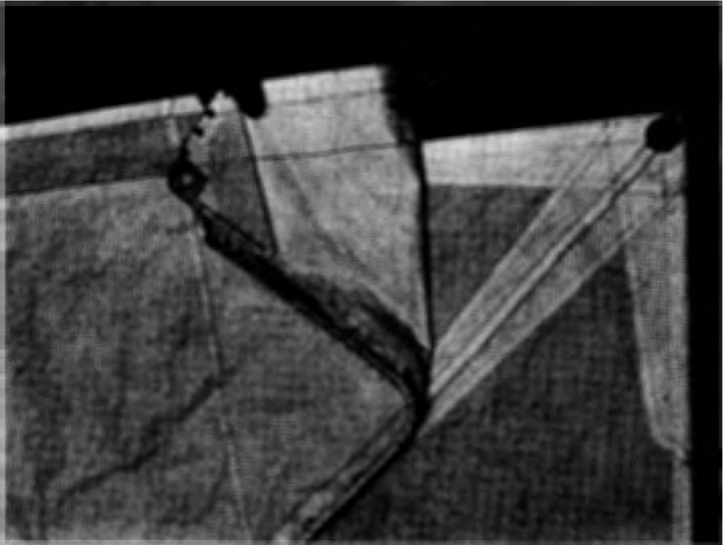

Be/ore M atching Head to Clew
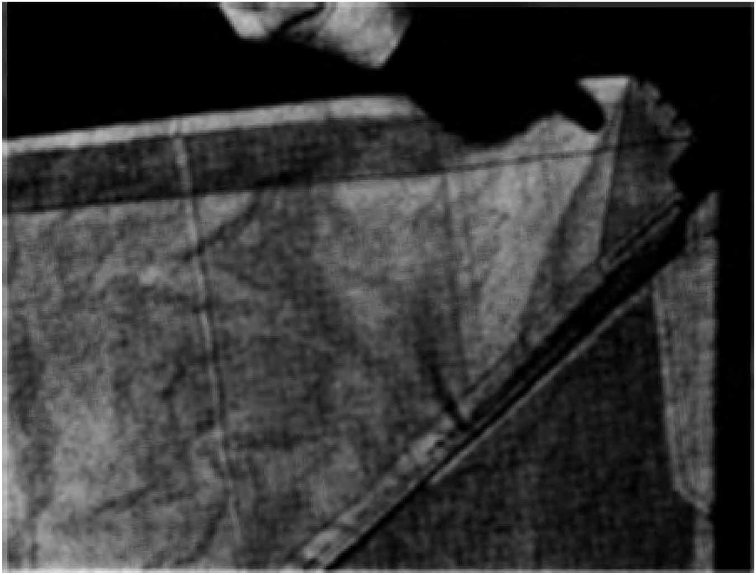
Head and Clew M atched

25

October, 1968

HOW TO FIND LEACH QUARTER POINTS (23.5.2 and 23.5.3)

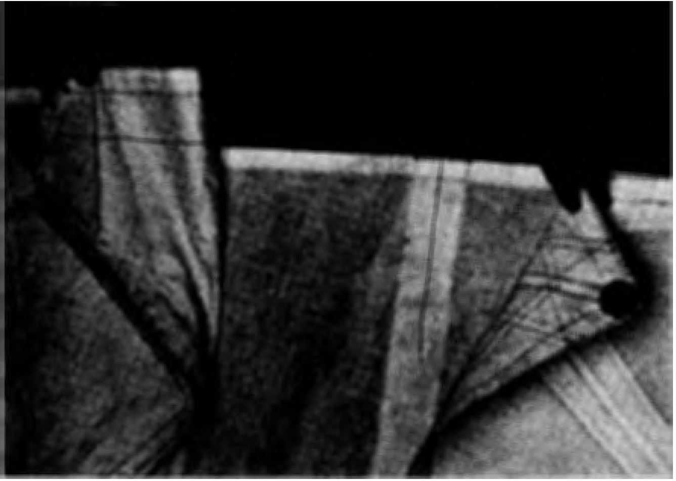

Before M atching Head and Clew to the M idpoint of the Leach

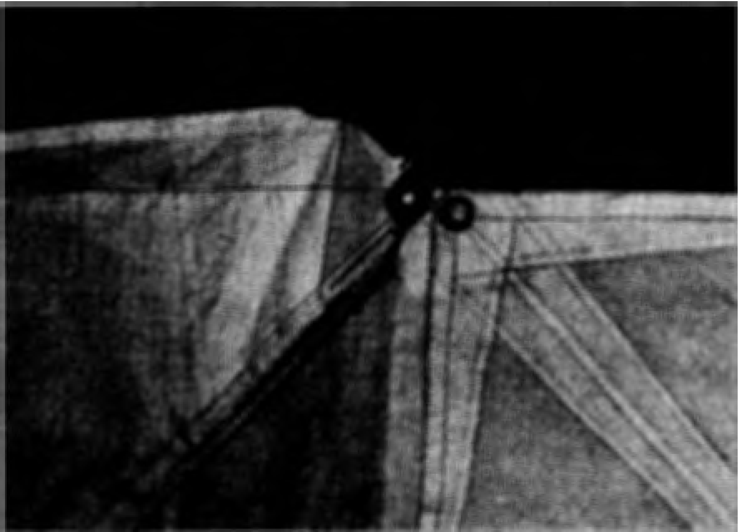

Head and Clew M atched to the Mid point of the Leach

26

October, 1968



ARTICLE XI-Racing Rules
I. The Racing Rules of the International Yacht Racing Union are the official racing rules of the International Penguin Class Dinghy Association except that Rule 33 is modified to permit continuance in a race after a foul, and Rules 31 and 52 are modified to provide for a graduated system of penalties in lieu of disqualification as follows:
(a ) Penalties for an infringement of the racing rules shall be assessed as stipulated by the class of violation outlined in paragraphs ( b ),
(c) and (d) but in no case shall any points be deducted in excess of the number of points earned by the guilty boat in a particular race.
- Class I violation Qf the rules consists of violation-s of the rules in which a boat, while violating a rule does not interfere with or put at a disadvantage any other contestant. If a boat is deemed guilty of a Class I infraction, not less than 2 points, or twenty per cent of the points of first place not including bonus points, whichever is greater, shall be assessed.
- ) Class II violation of the rules consists of violations wherein boats touch or rights are not granted or interferences occur but in which the advantage to the other boat is negligible or in which the boat having the rights does not change in position in the race at that point and due to that infraction of the rules. If a boat is deemed guilty of a Class II infraction, not less than 2 points, or forty per cent of the points of first place not including bonus points, which ever is the greater, shall he assessed.
(d ) Class III violations of the rules consist of violations wherein colli sion occurs, rights are not granted or interferences occur which result in a major disadvantage to the boat holding rights or in which the boat holding rights loses position in the race at that time due to that infraction. If a boat is deemed guilty of a Class III infraction, not less than four points, or eighty per cent of the points of first place not including bonus points, whichever is greater, shall be assessed.
(e) A boat found guilty of the infraction of any rule shall forfeit bonus points of first, second or third places. The percentage points of first place shall be calculated to the nearest tenth.
(f) In cases of collision which disables a boat so that it becomes neces sary to abandon the race, the boat responsible of violating a rule shall receive a penalty of all points.earned in that race.

27

ing:
ARTICLE XII-Scoring and Prise•
- A boat shall earn points for each race in accordance with the follow·

(a ) One point for finishing.
(b ) One point for each boat defeated ; boats making a proper start and not finishing are considered as boats defeated.
(c ) A bonus of seven-tenths of a point for finishing first.
( d ) A bon us of th ree-tenths of.a point for finishing second. ( e ) A bon us of one-tenth of a point for finishing third.
- In a series, total points will be awarded on the basis of the greatest

number of boats in any one race of the series.
- ( a ) In case of a tie between two crews for any place in a series, the issue shall be determined by one of the following methods and in the following order:
l . The crew which finished ahead of the other the greatest number of times shall he declared the winner of the place tied for.
2. The crew which won the greatest number of first places shall be declared the winner of the place tied for, and the other crew shall be decla red the winner of the next succeeding place. If the tied crews have won an equal number of first places, then sec· onds, thirds, fourths, etc., shall be taken into consideration in breaking the tie.
( b ) ln the case of a tie between t hree or more crews for any place i n a series, each tied crew shall be awarded one point for each race of the series for each of the other tied crews defeated by it. The crew thus awarded the greatest nu mber of points shall be decla red the winner .of the place tied for. The crew thus awarded the next greatest number of points shall be declared the winner of the next succeeding place, and so on, until all tied crews have been awarded places.
( c) If any tie cannot be broken by applying any of the foregoing methods, the Judges, if appointed, or the Race Committee may order a single sail-off and should seek out the tied contestants and arrange for a sail-off while the tied contestants are still on the water if possible. The spin of a coin as a deciding factor should be a rnided as much as possible.
- If a boat is disabled through an accident in which she is the innocent victim of a foul, the Judges, if appointed, or the Race Committee may, in their sole discretion either :
(a ) Award such boat a point or points as if it hid h'een unimpaired, especially if she be disabled late in the race, or
( b ) Await completion of the Series and award the disabled boat for that one race her average of points awarded in the other races she sailed in the series.
( c) Order the race resailed.
- Prizes shall be awarded on the basis of points earned for the series minus any penalties imposed by the Race Committee for infractions of rules.

28

ARTICLE XIII
These By-Laws may be amended, at any time, by a two-thirds vote of the Executive Committee.
Note: With reference to Article X, Sec. 2, the minimum weight clause ; it is recommended that the hull be weighed at a coal yard or in other certified scales. If these are not available, the boat can be weighed by turning upside down and placing stem on one bathroom scale and transom on another. Just total the two readings.

General Notes
The designer of the Penguin plans has assigned all rights and title to the International Penguin Class Dinghy Association, and plans may be purchased only through the Business Secretary of the Association. The fee for plans is
$15.00 payable to the International Penguin Class Dinghy Association. The plans consist of lithographed prints of the lines and offsets, construction drawings, sail plan, detailed spar drawing, full size templates for all frames, stem and stern knees and centerboard trunklogs. _
The International Penguin Class Dinghy Association has no interest in, or affiliation with, any professional yacht builder, and the plans are available lo ammteur and professional builders alike.
The Association will refuse to issue a number or grant a measurement certificate to any boat on which the number tax has not been paid or which was not built from a recorded set of Penguin plans. A number tax of $10 must be paid by a builder to the Association on each boat built from a set of plans. No boat may properly be sold, or entered in any race as a Penguin, or at any time display the Penguin Emblem upon its sails or otherwise, unless the number tax on such boat has been paid to the Association .by the builder or owner thereof. For the benefit of owners, and prospective owners, the Association proposes to take whatever steps that may he necessary to protect the name and Emblem from any unauthorized use.

Measurement Regulations
  - Measurements shall be made by the owner, builder, or a measu rer of a Yacht Club.
- This measurement sheet shall be forwarded in duplicate to the Chair·
man, International Measurement Committee, who shall approve or reject the boat as a class member accordingly if boat is within or beyond the building tolerances established by the ruling committee.
The registration of your boat is not complete until your Measurement Certificate has been approved by the International Measurement Committee. Only measured boats are permitted to race in the sanctioned events.
- Boats shall be subject to re-measurement as to dimensions and data on the measurement sheet upon protest. The person protesting shall post a bond of $2.00 as evidence of good faith, which shall be used to pay the measurer if the measurements are in accordance with those on the boat's measurement sheet. If dimensions fail to check with those submitted on the measurement sheet, the bond shall be returned and owner shall pay re-measurement fee, which shall not exceed $2.00. Re-measuremenrshall be made by the measurer appointed by the Race Committee having control of the races.

29
Procedure for Measuring Penguin Dinghy
L With the boat ;ight side u p, measure its length from stem head to af ter side of transom (see measurement sheet ) .
- Divide this measu red length by 4.
- Measure from the stern and mark with chalk, the 114, 1/2 and % length
of the boat. (Sections A, B, C, D, on sketch ) .
- Measu re the beam of the boat ( dimension Q ) at sections A, B, C, D.
- Turn the boat upside down and stretch tightly a chalk line ( hard cotton string ) located over the center of the boat and six inches above the stem and transom (see measurement sheet ) . This is most easily accomplished by setting a light post up forward and af t, and adjusting the string to the height and centerline specified above.
- Mark sections A, B, and C on the boat by using a flexible batten and chalk or by snapping a chalk line. (This is done by running a hard cotton line through chalk, stretching it tightly over the section to be marked, raising the center line and letting it snap back onto the section.)
- Make the measurements described on the measurement sheet in d uplicate.
- Upon com pletion send to the class measurer, Monte Clare, 2191 Mesa Drive, Santa Ana, Calif.

Fleet Charters
The Executive Vice President issues new Fleet Charters in accordance with Article VII, Section 2, of the Constitution, and other considerations set forth herein. The first prerequisite is a fleet organization. The minim um requirement calls for three Active Members of the l.P.C.D.A.-that is, paid-up members owning measured boats. However, a fleet of three boats is only a start-fleets do not develop succesfully unless there are more potential mem bers, boats under construction or other plans for progressive ex pansion. Another quite vital element is the sponsorship or backing of a yacht cl ub or other responsible organization-not an absolute necessity, but it is a big help to have a home port and a race committee to call u pon.
When presenting a request for a Fleet Charter, it is necessary to include: proposed fleet name, home port, names of fleet officers and roster of boats and members. The latter should include: name of member, address of mem· her, num ber of boat and name of boat. If there are Associate Members of the I.P.C.D.A. in the fleet, their names and addresses should be included on a separate list. Forwarding this information in duplicate will enable the Executive Vice President to send one copy to the Secretary for his records.
The name of the Fleet should be of pu rely local significance, omitting the words "Yacht Club." In most cases, the name of the body of water on which the fleet sails or its home port should be used.

30

Procedure for Chartering School, College, or Other Organization Fleets

inghys Owned by Sailing Club
    - Dinghys shall be registered in the name of the Cl ub. Dues for one Active Membership shall be paid by the Club.
    - Properly qualified Racing Skippers of the Club shall pay dues and be listed as Active Members (co-owners) by virtue of their membership in the Club. Skippers in sanctioned events shall be Active Members.
    - Members of the Club who do not qualif y as Racing Skippers, who crew in sanctioned events, shall pay dues and be listed as Associate Members.
    - Dues shall be optional for other members of the Cl ub, who may be
Associate Members if desired.
    - Fleet Charter shall be issued to the ( name of school, college or organ ization ) Penguin Fleet upon the registration of three or more dinghys and Active Members. Fleet Officers shall normally be elected from among the Active Members of the Fleet. Membership shall be re stricted to members of the Club who are Active or Associate Members of the International Penguin Class Dinghy Association.

inghys Owned by Individuals of a Sailing Club
    - Dinghys shall be registered in the name of the individual owner or co-owners, who shall pay d ues as regular Active Members. Skippers in sanctioned events shall be Active Members.
    - (Same as A-3, see above, substitute "Active Member" for "Racing Skippers.")
    - (Same as A-4, see above.)
    - (Same as A-5, see above.)
Notes: I-Fleets orpanized as outlined above and having Active and Associate Members for Skippers and Crews in sanctioned events will thereby fulfill all the pertinent requirements of the Constitution and By-Laws of the Penguin Class Dinghy Association.
2-Fleets of the Club owned dinghys (Type A organization ) are particu larly desirable. Where dinghys are owned by individ uals (Type B ) , unless these are permanent residents of the school or college, the Fleet will not have the permanent character of the former type.

FLEET REPORTS-PENALTIES
We q uote from Article VII, Section 3, of the Constitution : "Each fleet shall be required to file an an nual report of
its activities and a com plete roster of fleet officers and members with the Secretary of the Association, during the month of January of each year, in order to renew its rights and privi leges under its charter. Charters may be suspended at any time by the Executive Committee at its discretion, but can only be revoked at the ann ual meeting for failure to maintain in good standing the minim um of three boats necessary for a new fleet, or f or adequate reasons."

31
'"CONSTRUCTION TIPS"

Read Speci fications Very Thoroughly
1. It is recommended that your boat be kept as light as possible without sacrificing strength ; however, a minim um weight limit on completed hull with centerboa rd, ready-to-go of 130 lbs. is a Class requirement.
- The inwale may be deleted ; this will necessi tate some revision to the shape of the breasthook and qua rter-knees ( these still must he 6" on each leg ) .
- Spruce or a good grade of cedar may be safely used for structu ral members in place of mahogany or oak.
- Use extra care in fitting the centerboard trunk to the keel ; poor fit results in leaks.
- You should protect the raw edges of plywood ; use a %" mahogany chine batten or cover with fi ber glass.
- It is easier to bevel the chines for good drainage before the ply wood skin is laid on.
- Mone! or copper-bronze boat nails can be used instead of brass screws for laying on the plywood skin.
- African mahogany is cheaper than Honduras or Philippine mahogany and generally will make a good rudder and centerboard. Don't use plywood for these.
- Sand all struct ura l members before assembly ; it's hard to do af ter wards.
- Treat the plywood with some good sealer such as "Firzite" or "Val-Oil" before painting or varnishing.
- "Famowood" makes a good cover over screw or nail heads.
- Bend a piece of copper or stainless steel tubing for use at the mast head and the end of the boom in place of a sheave.
- Mast tangs-should be placed somewhere between 4' and 5' below top of mast.
- Suggestions for Halyard-Wire halyard should he of Y16" s.s. cable;
provide a rope tail ; provide cable end with thimble and nicropress clamp; place a 11,4" brass screw about # 10 in the mast at a point where the halyard end raises the sail proper Iy ; allow the screw end to protrude about o/i.6 "--this
provides a secu re halyard hitch.
- Limber Holes-Be ;;;ure to provide adequate limber holes through the bittom ribs at the keel; some also have limber holes at the chines hut this may weaken the structure.
16, Centerboard Trunk-If centerboard trunk has tendency to warp inward, uae outside stiffeners between the head ledges as well as an interior stiffener at top of trunk.
- Stem Cap-should be made of mahogany or oak. Be sure to get a good tight fit as leaks often originate here.
- Mast-Partner-many boats have adjustable mast-partners and mast· steps so that the boat may be more finely tuned.
- Floorboards-if plywood floorboards are used, also use a stiffener along outer edge. It may crack otherwise.

32

